**Retro Basic Project Report**

Present To

Prabhas Chongstitvatana

Submitted By

Paphawit Boonyapongnukul

(5931036021)

This project is parted of Programming Languages Principles (2110316)

Section 33 Semester 1 Year 2018

Chulalongkorn University

Retro Basic (implemented in Python)

**Part I: Scanner**

Tokenize streaming of character from each line of file by using spilt method in python and get list of tokens considering “Blank Space” as delimiter.

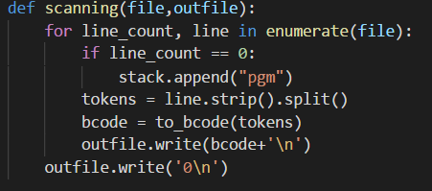

**Part II: Parser**

Put each token into stack and pop for check rule by parsing table if it’s not available raise an exception but if it does push all entry of parsing into stack and loop till terminal (reference algorithm form lecture slide).

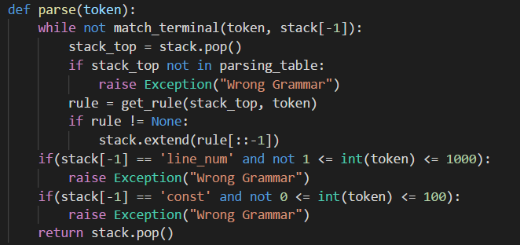

|  |  |
| --- | --- |
| pgm := line pgm | EOF line := line_num stmt stmt := asgmnt | if | print | goto | stop asgmnt := id = exp exp := term exp’exp’ := + term | - term | λ | term := id | const if := IF cond line_num cond := term cond’cond’ := < term | = term print := PRINT id goto := GOTO line_num stop := STOP |

**Grammar**

**First set & Follow set**

|  |  |  |
| --- | --- | --- |
| **Non-terminal** | **First** | **Follow** |
| pgm | line_num, EOF | $ |
| line | line_num | line_num, EOF |
| stmt | id, IF, PRINT, GOTO, STOP | line_num, EOF |
| asgmnt | id | line_num, EOF |
| exp | id, const | line_num, EOF |
| exp’ | +, -, λ | line_num, EOF |
| term | id, const | +, -, line_num, EOF |
| if | IF | line_num, EOF |
| cond | id, const | line_num |
| cond’ | <, = | line_num |
| print | PRINT | line_num, EOF |
| goto | GOTO | line_num, EOF |
| stop | STOP | line_num, EOF |

**Split Grammar**

1. pgm := line pgm
2. pgm := EOF
3. line := line_num stmt
4. stmt := asgmnt
5. stmt := if
6. stmt := print
7. stmt := goto
8. stmt := stop
9. asgmnt := id = exp
10. exp := term exp’
11. exp’ := + term
12. exp’ := - term
13. exp’ := λ
14. term := id
15. term := const
16. if := IF cond line_num
17. cond := term cond’
18. cond’ := < term
19. cond’ := = term
20. print := PRINT id
21. goto := GOTO line_num
22. stop := STOP

**Parsing Table**

|  |  |  |  |  |  |  |  |  |  |  |  |  |  |
| --- | --- | --- | --- | --- | --- | --- | --- | --- | --- | --- | --- | --- | --- |
|  | line_num | id | IF | PRINT | GOTO | STOP | + | - | const | < | = | EOF | $ |
| pgm | 1 |  |  |  |  |  |  |  |  |  |  | 2 |  |
| line | 3 |  |  |  |  |  |  |  |  |  |  |  |  |
| stmt |  | 4 | 5 | 6 | 7 | 8 |  |  |  |  |  |  |  |
| asgmnt |  | 9 |  |  |  |  |  |  |  |  |  |  |  |
| exp |  | 10 |  |  |  |  |  |  | 10 |  |  |  |  |
| exp’ | 13 |  |  |  |  |  | 11 | 12 |  |  |  | 13 |  |
| term |  | 14 |  |  |  |  |  |  | 15 |  |  |  |  |
| if |  |  | 16 |  |  |  |  |  |  |  |  |  |  |
| cond |  |  |  |  |  |  |  |  | 17 |  |  |  |  |
| cond’ |  |  |  |  |  |  |  |  |  | 18 | 19 |  |  |
| print |  |  |  | 20 |  |  |  |  |  |  |  |  |  |
| goto |  |  |  |  | 21 |  |  |  |  |  |  |  |  |
| stop |  |  |  |  |  | 22 |  |  |  |  |  |  |  |

**Code**

import sys

parsing_table = {

"pgm": {"line_num": ["line", "pgm"], "EOF": ["EOF"]},

"line": {"line_num": ["line_num", "stmt"]},

"stmt": {"id": ["asgmnt"], "IF": ["if"], "PRINT": ["print"], "GOTO": ["goto"], "STOP": ["stop"]},

"asgmnt": {"id": ["id", "=", "exp"]},

"exp": {"id": ["term", "exp'"], "const": ["term", "exp'"]},

"exp'": {"EOF": None, "line_num": None, "+": ["+", "term"], "-": ["-", "term"]},

"term": {"id": ["id"], "const": ["const"]},

"if": {"IF": ["IF", "cond", "line_num"]},

"cond": {"id": ["term", "cond'"], "const": ["term", "cond'"]},

"cond'": {"<": ["<", "term"], "=": ["=", "term"]},

"print": {"PRINT": ["PRINT", "id"]},

"goto": {"GOTO": ["GOTO", "line_num"]},

"stop": {"STOP": ["STOP"]},

}

bcode_type = {

"#line": 10,

"#id": 11,

"#const": 12,

"#if": 13,

"#goto": 14,

"#print": 15,

"#stop": 16,

"#op": 17,

}

id = set([chr(e) for e in range(ord('A'), ord('Z')+1)])

line_num = set([str(i) for i in range(1, 1001)])

const = set([str(i) for i in range(0, 101)])

terminal = set(["+", "-", "IF", "<", "=", "PRINT", "GOTO", "STOP", "EOF"])

stack = ["EOF"]

def get_terminal_type(token):

if token.isdigit():

return "num"

if token in id:

return "id"

if token in terminal:

return token

raise Exception('Wrong Input Grammar')

def match_terminal(token, top_stack):

terminal_type = get_terminal_type(token)

if terminal_type != "num":

return terminal_type == top_stack

else:

return top_stack == "line_num" or top_stack == "const"

def get_rule(stack_top, token):

terminal_type = get_terminal_type(token)

if terminal_type != "num" and terminal_type in parsing_table[stack_top]:

return parsing_table[stack_top][terminal_type]

if "line_num" in parsing_table[stack_top]:

return parsing_table[stack_top]["line_num"]

if "const" in parsing_table[stack_top]:

return parsing_table[stack_top]["const"]

raise Exception("Wrong Grammar")

def parse(token):

while not match_terminal(token, stack[-1]):

stack_top = stack.pop()

if stack_top not in parsing_table:

raise Exception("Wrong Grammar")

rule = get_rule(stack_top, token)

if rule != None:

stack.extend(rule[::-1])

if(stack[-1] == 'line_num' and not 1 <= int(token) <= 1000):

raise Exception("Wrong Grammar")

if(stack[-1] == 'const' and not 0 <= int(token) <= 100):

raise Exception("Wrong Grammar")

return stack.pop()

def get_bcode(terminal_symbol, value):

if(terminal_symbol == "line_num"):

return ("#line", int(value))

if(terminal_symbol == "id"):

return ("#id", ord(value) - ord('A') + 1)

if(terminal_symbol == "const"):

return ("#const", int(value))

if(terminal_symbol == "IF"):

return ("#if", 0)

if(terminal_symbol == "GOTO"):

return ("#goto", int(value))

if(terminal_symbol == "PRINT"):

return ("#print", 0)

if(terminal_symbol == "STOP"):

return ("#stop", 0)

if(terminal_symbol == "+"):

return ("#op", 1)

if(terminal_symbol == "-"):

return ("#op", 2)

if(terminal_symbol == "<"):

return ("#op", 3)

if(terminal_symbol == "="):

return ("#op", 4)

def gen_bcode(parsed_list):

bcode_list = []

for i in range(len(parsed_list)):

if(parsed_list[i][0] not in ["GOTO", "line_num"] or i == 0):

bcode_list.append(get_bcode(parsed_list[i][0], parsed_list[i][1]))

else:

if(parsed_list[i][0] == 'line_num' and i != 0):

bcode_list.append(get_bcode("GOTO", parsed_list[i][1]))

return bcode_list

def to_bcode(tokens):

parsed_list = []

for token in tokens:

parsed_list.append((parse(token), token))

bcode_list = gen_bcode(parsed_list)

bcode_string = ''

for types, value in bcode_list:

bcode_string = bcode_string + \

str(bcode_type[types]) + ' ' + str(value) + ' '

return bcode_string.strip()

def scanning(file,outfile):

for line_count, line in enumerate(file):

if line_count == 0:

stack.append("pgm")

tokens = line.strip().split()

bcode = to_bcode(tokens)

outfile.write(bcode+'\n')

outfile.write('0\n')

file_input = str(sys.argv[1])

file = open(file_input, 'r')

file_output = open('result_of_'+file_input+'.txt', 'w')

scanning(file,file_output)

file.close()

file_output.close()

**Repository of code and document**



<https://github.com/chinyyyyyyyy/RetroBasic2018>